Assignment1_Template
For the variable ‘Height’ in the ‘trees’ data set, complete the following tasks.
A) Calculate the mean, variance, and standard deviation. (20 pts)
[1] 76
[1] 40.6
[1] 6.371813
B) Make a frequency distribution table. Make sure it includes the frequency, relative frequency, cumulative frequency and cumulative percentage. Do not exlude values which have a frequency of 0 (zero). Make sure your table is presented in APA style. Do not group the data into intervals. (60 points)
Height | f | Relative f | Cumulative f | Cumulative %
63 | 1 | 0.03 | 1 | 3
64 | 1 | 0.03 | 2 | 6
65 | 1 | 0.03 | 3 | 10
66 | 1 | 0.03 | 4 | 13
67 | 0 | 0 | 4 | 13
68 | 0 | 0 | 4 | 13
69 | 1 | 0.03 | 5 | 16
70 | 1 | 0.03 | 6 | 19
71 | 1 | 0.03 | 7 | 23
72 | 2 | 0.06 | 9 | 29
73 | 0 | 0 | 9 | 29
74 | 2 | 0.06 | 11 | 35
75 | 3 | 0.1 | 14 | 45
76 | 2 | 0.06 | 16 | 52
77 | 1 | 0.03 | 17 | 55
78 | 1 | 0.03 | 18 | 58
79 | 1 | 0.03 | 19 | 61
80 | 5 | 0.16 | 24 | 77
81 | 2 | 0.06 | 26 | 84
82 | 1 | 0.03 | 27 | 87
83 | 1 | 0.03 | 28 | 90
84 | 0 | 0 | 28 | 90
85 | 1 | 0.03 | 29 | 94
86 | 1 | 0.03 | 30 | 97
87 | 1 | 0.03 | 31 | 100
Total | 31
C) Make a frequency distribution graph with the normal curve superimposed on it. Plot the scores on the x axis and the frequency on the y axis. Make sure your graph is presented in APA style. Do not group the data into intervals. Finally, describe the distribution as you have been instructed in class (not as ‘pretty,’ ‘fun,’ ‘strange,’ etc.). (30 points)
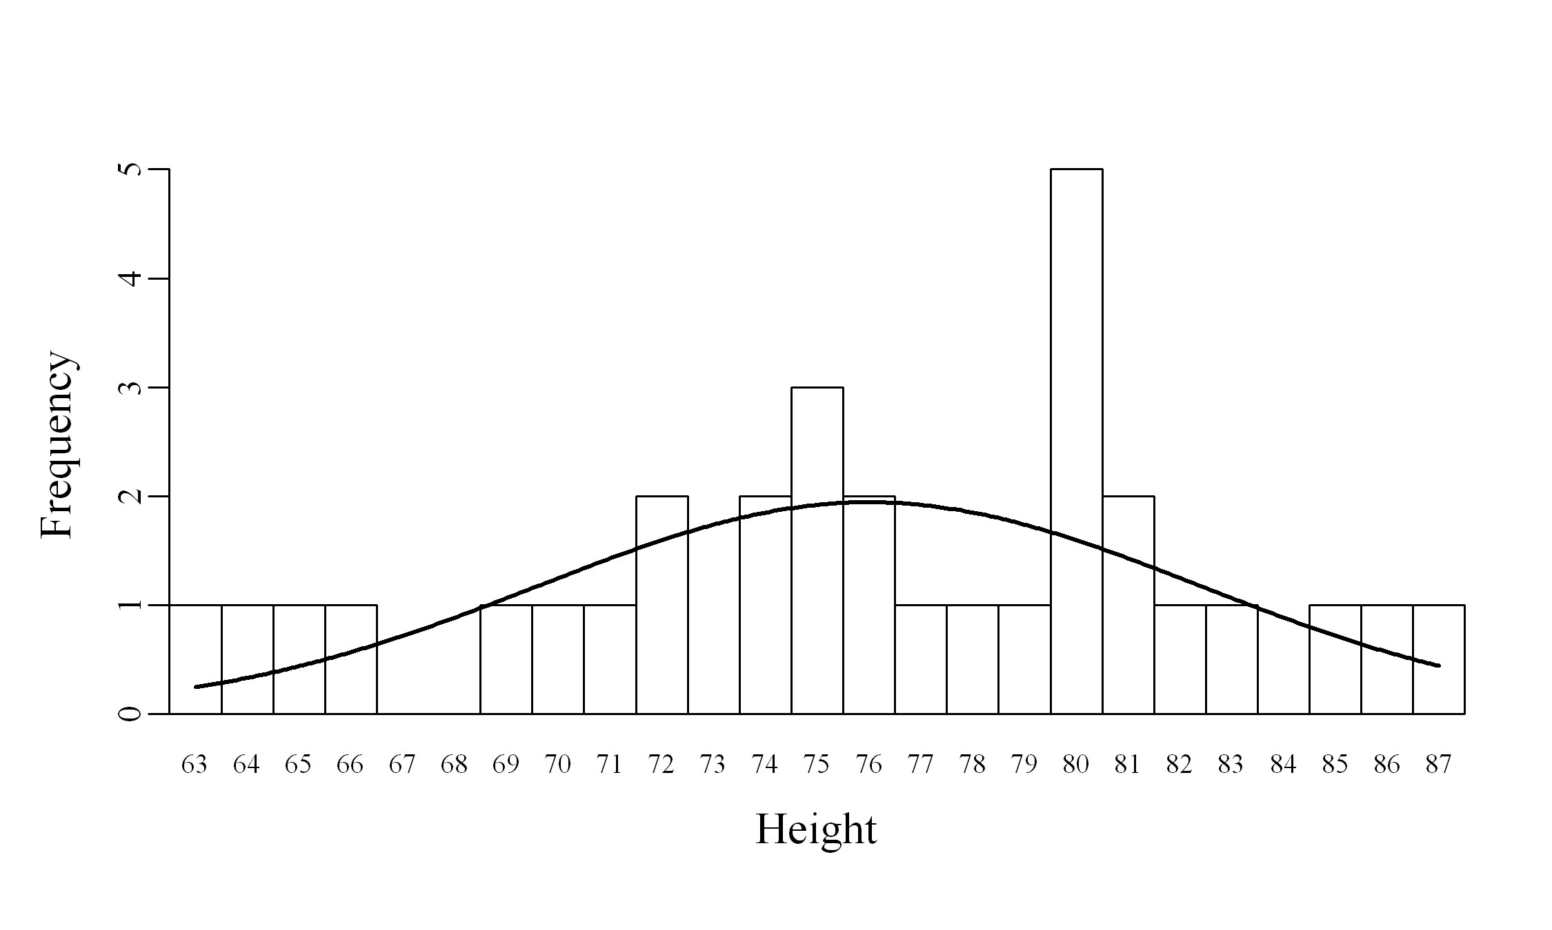
D) Make a histogram of the frequency data. Looking at the histogram, describe the distribution as you have been instructed in class (not as ‘pretty,’ ‘fun,’ ‘strange,’ etc.). (15 points)
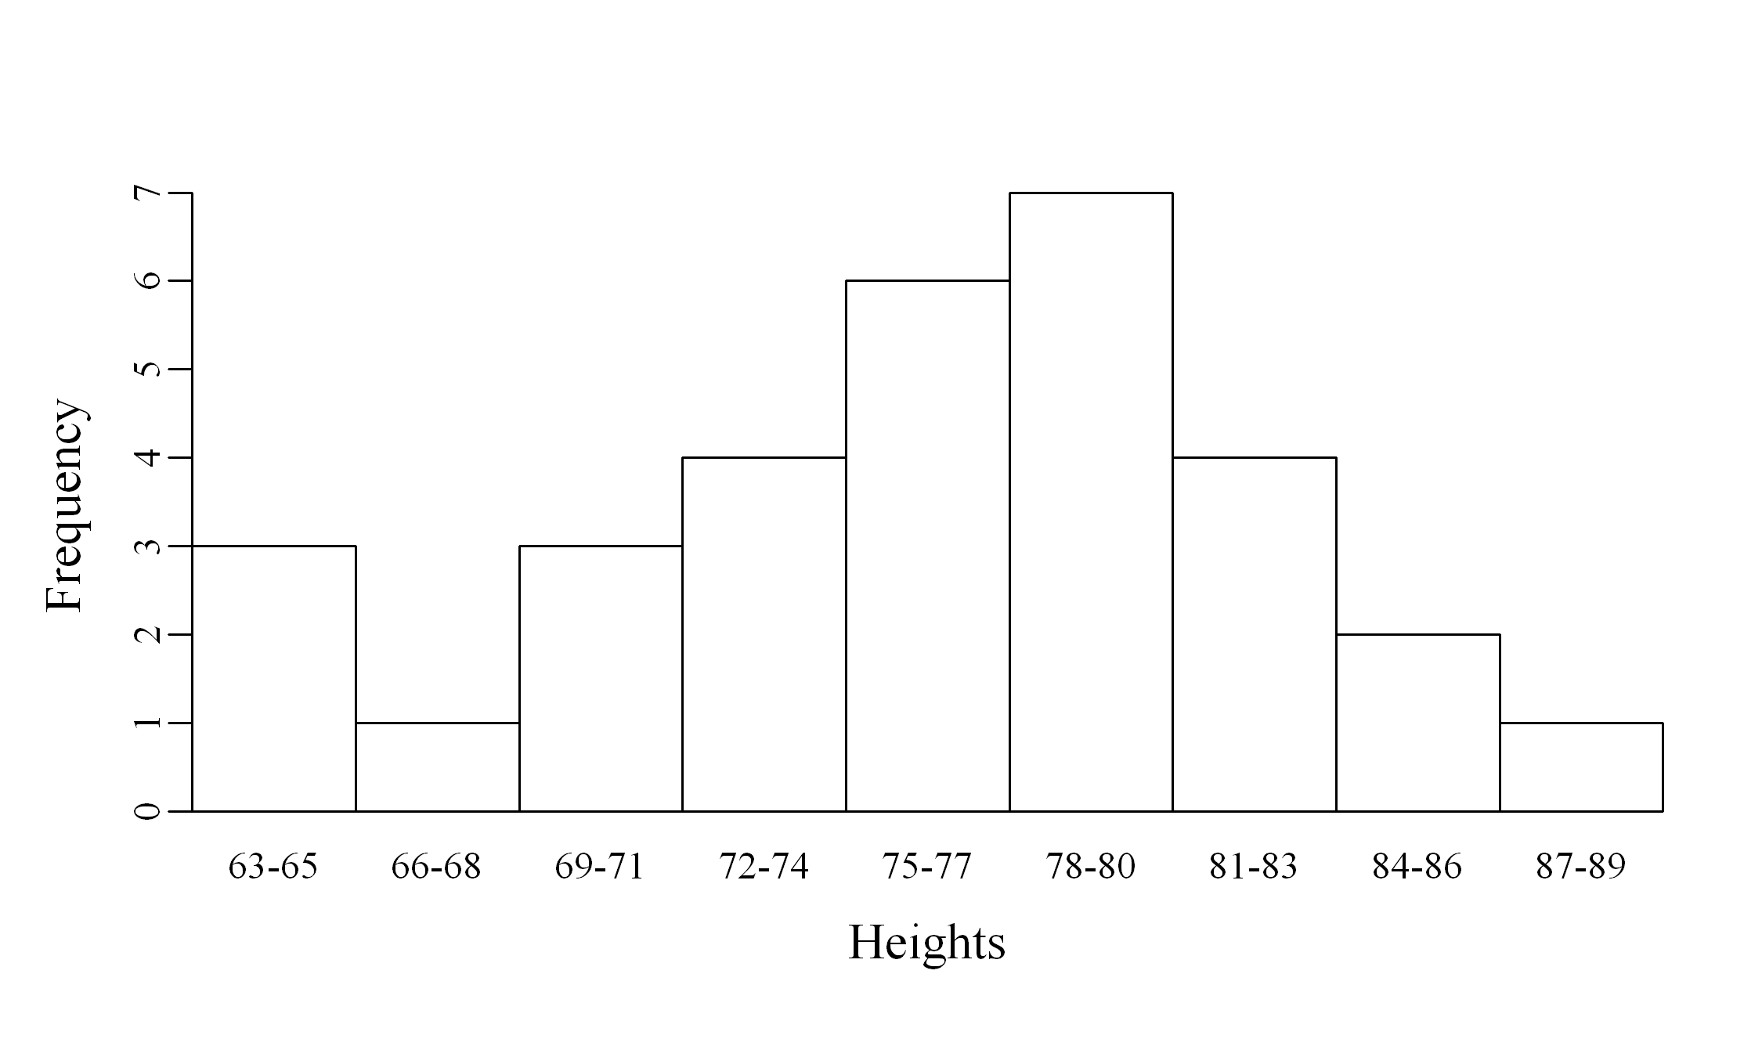
E) Make a boxplot. (10 points)
